**Updating Perform harness:**

**Perform harness is called on each assignment in the flow. This is responsible for loading Flow action at each assignment.**

**Under Assignment shape Properties ( U will have Perform Harness)**

**Perform Harness:**

**Below are the sections we have under Perform Harness:**

**Header Panel / Action Area: pyCaseHeaderOuter**

**Flowaction Area: pyCaseActionArea**

**Case Deatils: pyCaseDetails**

**Case Information: pyCaseInformation**

**Open Assignments: pyCaseContents ( Main Section)-> pxLocalAction -> pyCaseContentGadget( FlowAction)**

**Req: Update Perform Harness & Add Header( Actions area) , Flowaction Area & Open Assignments Link(Operator Info & Where am I)**

**Open Perform Harness from any Assignment shape:**

**Flow-> Assignment shape-> Advanced settings-> Assignment Details-> Perform Harness**

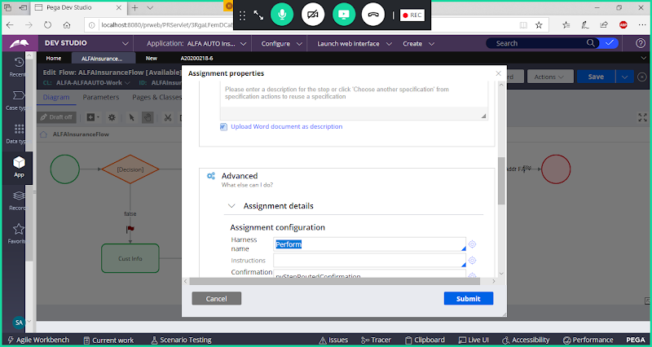

**Open perform harness**

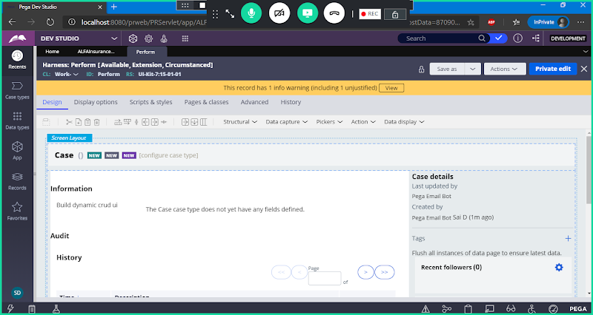

**Use Save as**

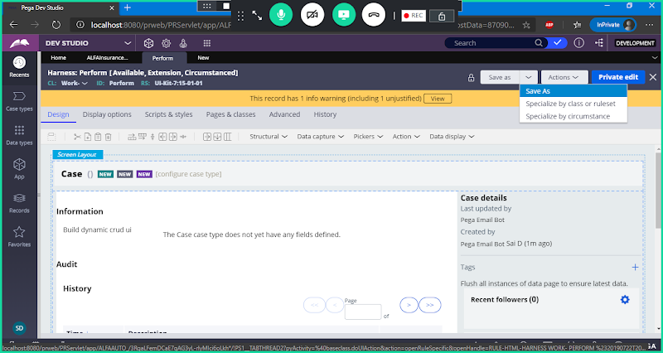

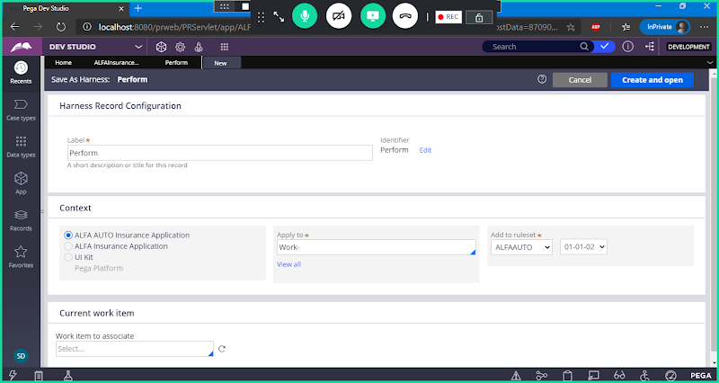

**No need to Change Rule name & Classname**

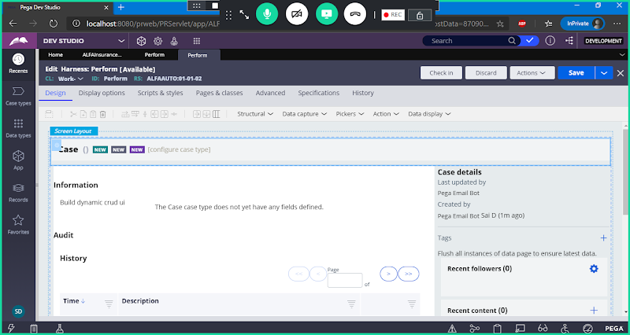

**Select Panels & Click on delete**

**Delete Panel**

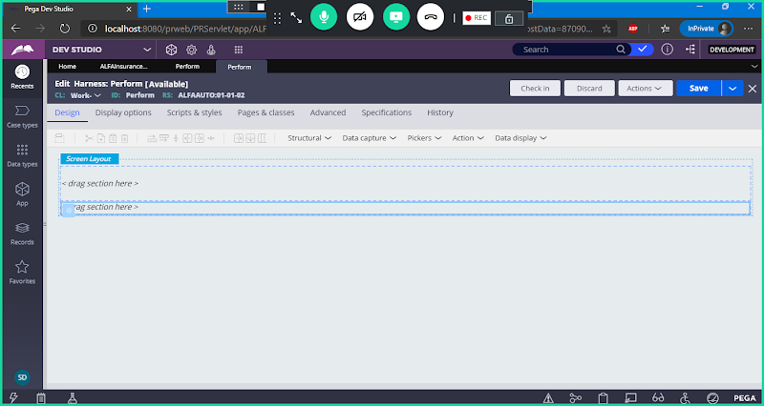

**Double Click on Screen layout settings**

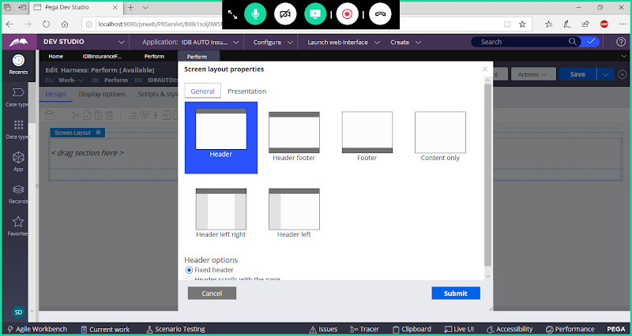

**Select Header Footer & Submit**

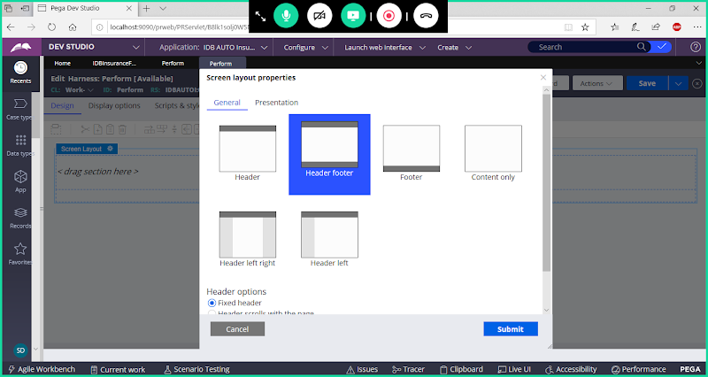

**Click on Submit**

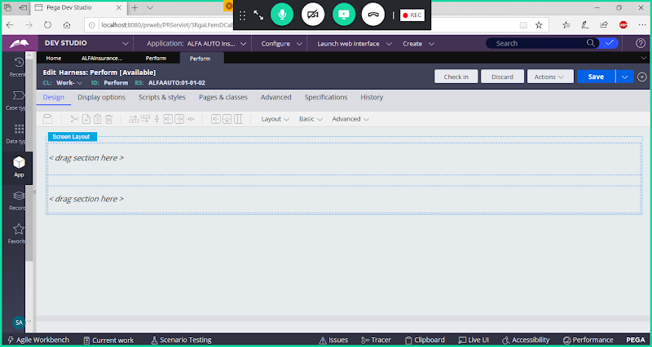

**Double Click on Section1**

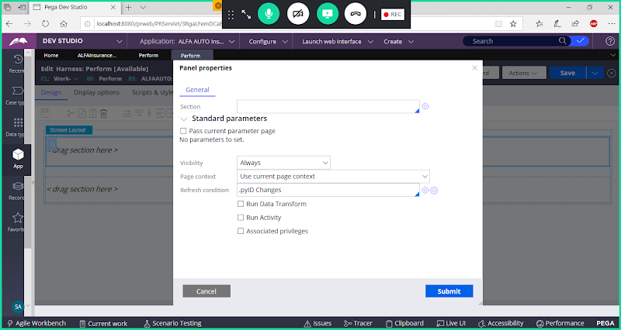

**Select section : pyCaseHeaderOuter**

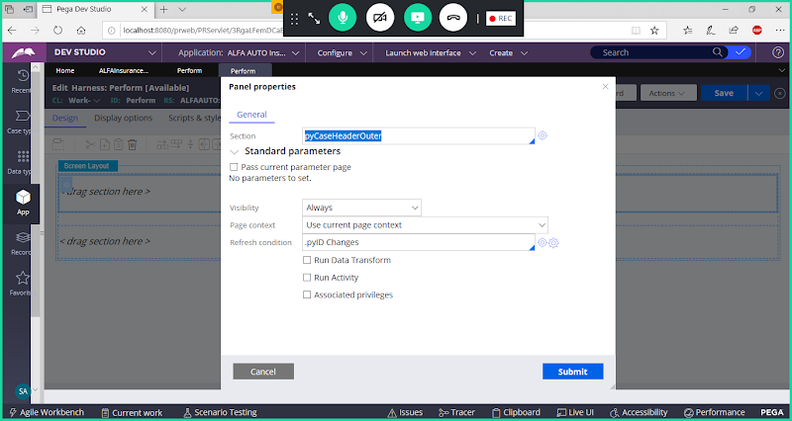

**Submit**

**Double Click on Second Section**

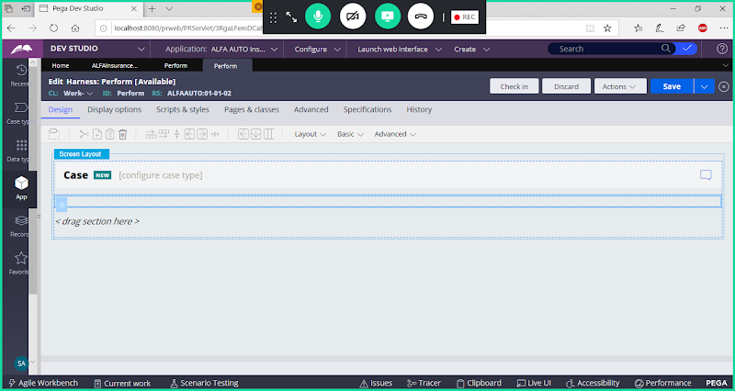

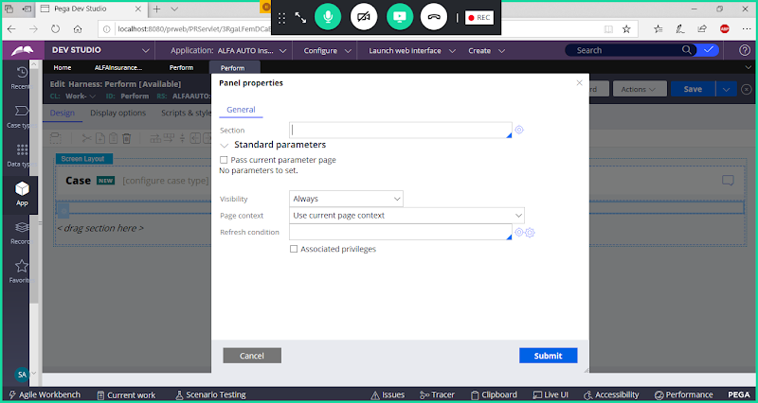

**Add pyCaseActionArea section**

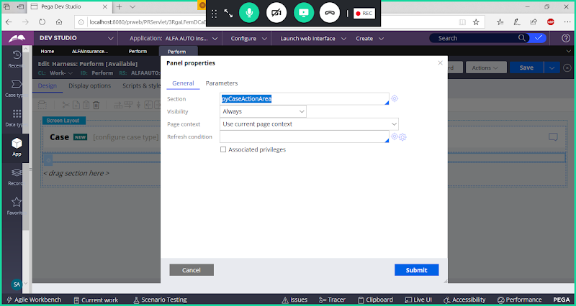

**Submit**

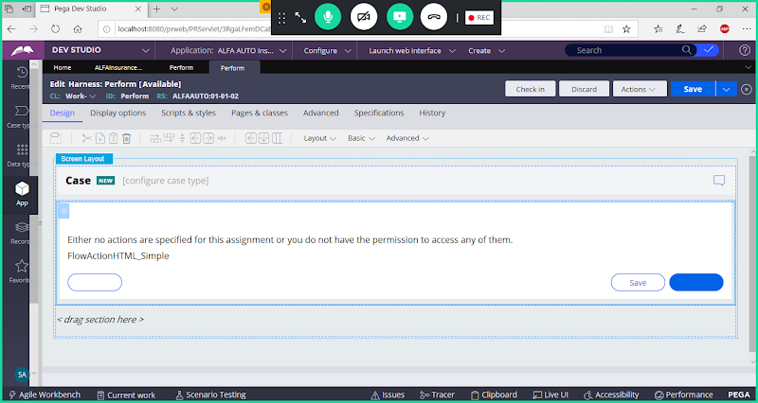

**Double Click on Section 3**

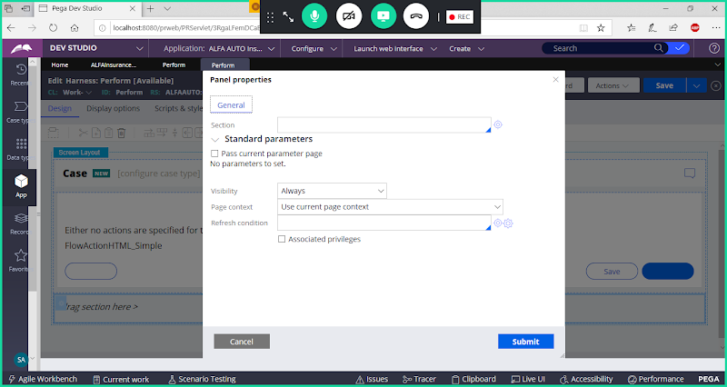

**SectionName: pxLocalAction**

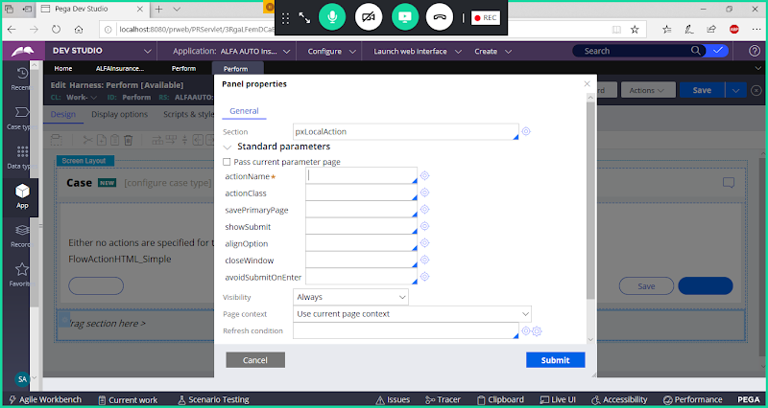

**Now Add Parameters under pxLocalAction:**

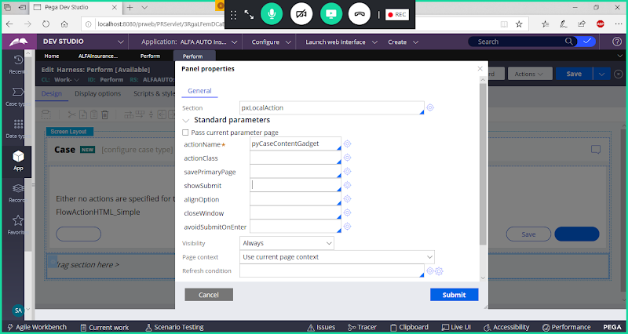

**Add ShowSubmit as false**

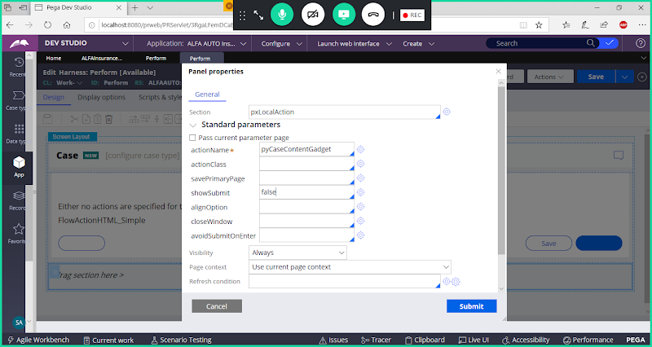

**Submit**

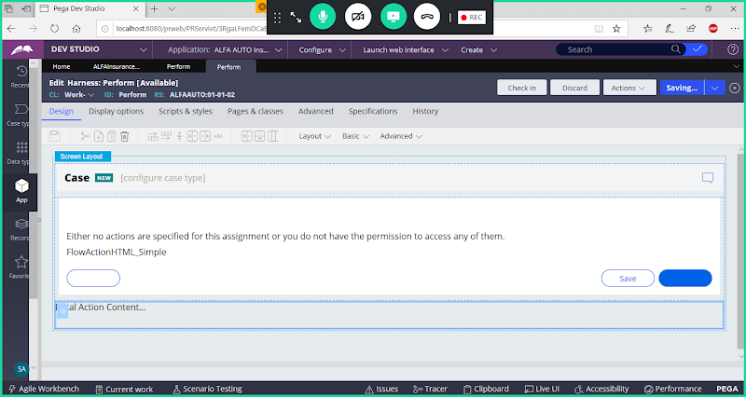

**Save Harness**

**Run Insurance Flow**



